Module 1.2

What is Underfitting and Overfitting in machine learning and how to deal with it.
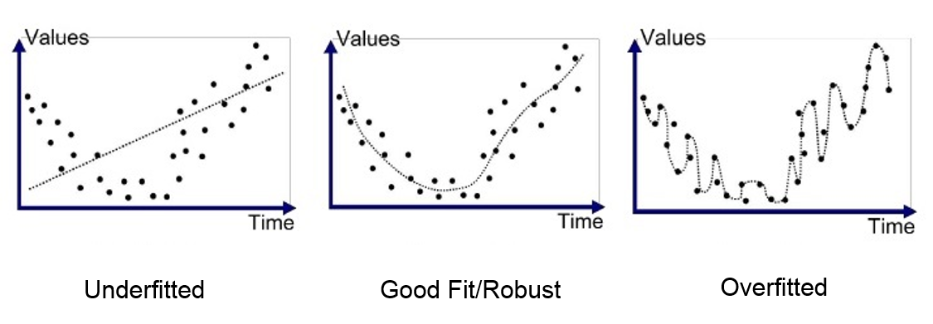
Whenever working on a data set to predict or classify a problem, we tend to find accuracy by implementing a design model on first train set, then on test set. If the accuracy is satisfactory, we tend to increase accuracy of data-sets prediction either by increasing or decreasing data feature or features selection or applying feature engineering in our machine learning model. But sometime our model maybe giving poor result.
The poor performance of our model maybe because, the model is too simple to describe the target, or may be model is too complex to express the target. Why this happened? And how to deal with it?

Why Our model perform poor sometime?
So here comes the concept of overfitting and underfitting. Overfitting and underfitting can be explained using below graph.
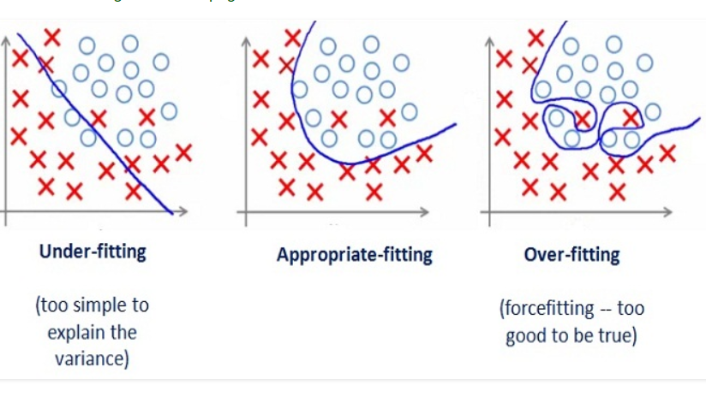
By looking at the graph on the left side we can predict that the line does not cover all the points shown in the graph. Such model tend to cause underfitting of data .It also called High Bias.
Where as the graph on right side, shows the predicted line covers all the points in graph. In such condition you can also think that it’s a good graph which cover all the points. But that’s not actually true, the predicted line into the graph covers all points which are noise and outlier. Such model are also responsible to predict poor result due to its complexity.It is also called High Variance.
Now, Looking at the middle graph it shows a pretty good predicted line. It covers majority of the point in graph and also maintains the balance between bias and variance.
In machine learning, we predict and classify our data in more generalized way. So in order to solve the problem of our model that is overfitting and underfitting we have to generalize our model. Statistical speaking how well our model fit to data set such that it gives proper accurate results as expected.

Now the question comes, How to differentiate between overfitting and underfitting?
Solving the issue of bias and variance is really about dealing with over-fitting and under-fitting. Bias is reduced and variance is increased in relation to model complexity. As more and more parameters are added to a model, the complexity of the model rises and variance becomes our primary concern while bias steadily falls.
What is bias, variance and their importance in predicting model.
Bias: It gives us how closeness is our predictive model’s to training data after averaging predict value. Generally algorithm has high bias which help them to learn fast and easy to understand but are less flexible. That looses it ability to predict complex problem, so it fails to explain the algorithm bias. This results in underfitting of our model.
Getting more training data will not help much.
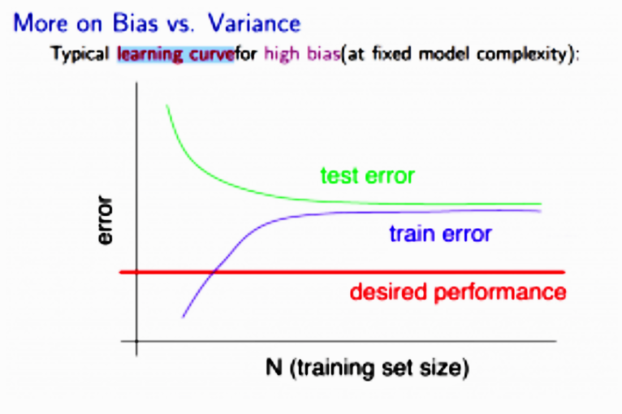
Variance: It define as deviation of predictions, in simple it is the amount which tell us when its point data value change or a different data is use how much the predicted value will be affected for same model or for different model respectively. Ideally, the predicted value which we predict from model should remain same even changing from one training data-sets to another, but if the model has high variance then model predict value are affect by value of data-sets. The Graph below shows the path when a learning algorithm suffers from High Variance. This show getting more training data will help to deal with it.
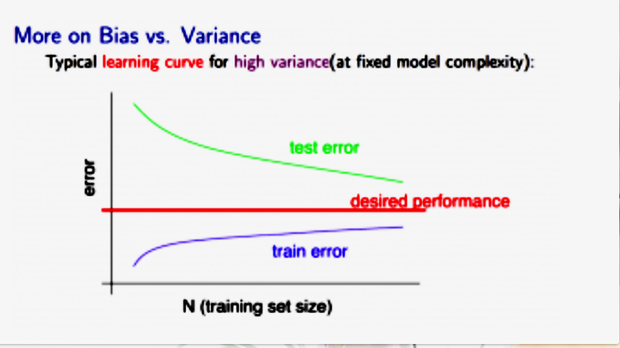

How to overcome it? And what are the techniques?
The method to overcome this overfitting and underfitting problem we have to see them separately one by one.

1 .Underfitting:
In order to overcome underfitting we have to model the expected value of target variable as nth degree polynomial yeilding the general Polynomial.The training error will tend to decrease as we increase the degree d of the polynomial.
The mathematical presentation can be give as,
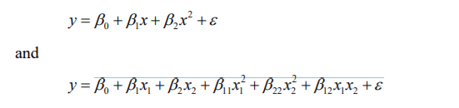
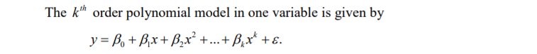
The training error will tend to decrease as we increase the degree d of the polynomial. At the same time, the cross validation error will tend to decrease as we increase d up to a point, and then it will increase as d is increased, forming a convex curve.
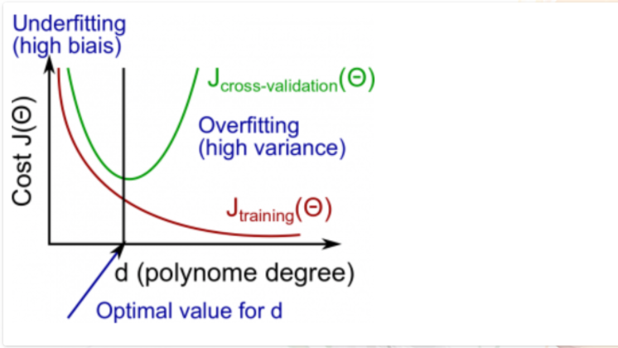
This concept of implementing this model is said Polynomial Regression, to get insight of Polynomial Regression. Polynomial projection is built into scikit-learn using the polynomial feature transform.

2. Overfitting:
To solve the problem of overfitting in model we need to increase flexibility of our model. But too much of his flexibility can also spoil our model, so flexibility shold such that it is optimal value. To increase flexibility we can use regularization technique.
They are three types of regularization technique to overcome overfitting.
a) L1 regularization (also called Lasso regularization / panelization.)
b) L2 regularization (also called Ridege regularization/ penalization.)
c) Elastic net

What is Overfitting?
- Overfitting happens when a model learns the training data too well, including the noise and random fluctuations.
- As a result, the model performs great on training data but poorly on new, unseen data (bad generalization).

How Regularization Helps
Regularization is a technique used to reduce overfitting by adding a penalty to the model’s complexity during training. This penalty discourages the model from fitting the noise and forces it to keep the model simpler.

Common Types of Regularization
- L2 Regularization (Ridge Regression)
  - Adds the sum of the squared weights (parameters) multiplied by a small factor (lambda) to the loss function.
  - Formula (loss function):
Loss=Original Loss+λ∑wi2
Loss = Original Loss + lambda sum w_i^2
  - Effect: Penalizes large weights, encourages smaller weights, which smooths the model.
• The parameter alpha controls the strength of the regularization:
- Larger alpha means stronger regularization (more penalty on large coefficients).
- Smaller alpha means weaker regularization.
• By including this penalty, the model’s coefficients are shrunk to prevent overfitting.

- L1 Regularization (Lasso Regression)
  - Adds the sum of the absolute values of the weights multiplied by lambda.
  - Formula:
Loss=Original Loss+λ∑∣wi∣
Loss = OriginalLoss + lambda sum |w_i|
  - Effect: Can shrink some weights to zero, effectively performing feature selection by ignoring less important features.
- Dropout (for Neural Networks)
  - Randomly "drops out" (sets to zero) a fraction of neurons during each training step.
  - Effect: Prevents co-adaptation of neurons, making the network more robust and less likely to overfit.
- Early Stopping
  - Stops training once the performance on a validation set starts to degrade.
  - Effect: Prevents the model from learning noise in the training data by limiting training time.

What’s happening here?
- The Lasso model adds an L1 penalty to the loss function.
- The alpha parameter controls how strong this penalty is.
- Because of L1 regularization, some coefficients can become exactly zero, effectively removing those features.
- This means Lasso also performs feature selection while preventing overfitting.

It stand for” least absolute shrinkage and and selection operator
Things we need to reduce the overfitting of data, the ‘P’ term should be added to existing model and alpha is learning rate. Lasso method overcome the disadvantage of Ridge regression by not furnishing high value of the coefficient but actually setting them to 0 you they are not relevant, therefore you might end with fewer features including the model you started with, which is the huge advantage.

Limitation of Lasso:
i) If p>n, the lasso selects at most n variables. The number of selected genes is bounded by the number of samples. Where ‘p’ is number of data and ’n’ are train and test samples.
ii) Grouped variables: the lasso fails to do grouped selection. It tends to select one variable from a group and ignore the others.

Why Regularization Works?
- It adds a constraint on model parameters, limiting the complexity.
- This reduces the model’s ability to memorize noise and forces it to learn general patterns.
- Helps achieve a better balance between bias and variance.

3. Elastic:
Working of Elastic regularization is such that it work by implementing both i.e Lasso and Ridge together. Hence, it work more better then both individual. The elastic net solution path is piece wise linear. The mathematical representation is given as,
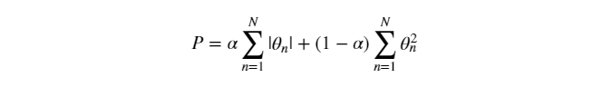
The advantage of Elastic regularization is that it overcome limitation of both Lasso and Ridge to some extent.
Conclusion:
Applying machine learning model on data-sets directly, will not predict our accuracy as we expected and it may be full of overfitting or underfitting representation on our training data.

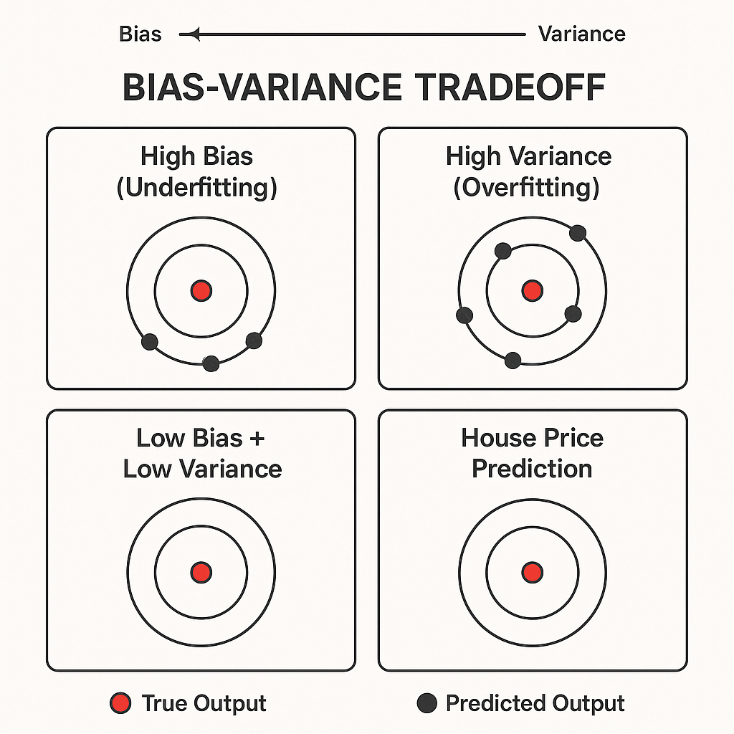

Conclusion

Overfitting, Underfitting & Bias-Variance Tradeoff
- Overfitting
  - The model learns the training data too well, including its noise and outliers.
  - Performs well on training data but poorly on new/unseen data.
  - Causes: Too complex model, too many features, insufficient training data.
  - Solution: Simplify model, use regularization, cross-validation, collect more data.
- Underfitting
  - The model is too simple to learn the underlying pattern of the data.
  - Performs poorly on both training and test data.
  - Causes: Overly simplistic model, not enough features, too few training epochs.
  - Solution: Use more complex models, add relevant features, reduce bias.
- Bias-Variance Tradeoff
  - Bias: Error due to wrong assumptions in the learning algorithm. High bias leads to underfitting.
  - Variance: Error due to model's sensitivity to small fluctuations in the training set. High variance leads to overfitting.
  - Tradeoff: Increasing model complexity decreases bias but increases variance, and vice versa.
  - Goal: Find a balance where both bias and variance are low to achieve good generalization on unseen data.

Bias-Variance Tradeoff in Machine Learning

What Is It?
The bias-variance tradeoff is a fundamental concept that describes the balance between two sources of error in machine learning models:
Component | Description | Typical Problem
Bias | Error from wrong assumptions in the model | Underfitting
Variance | Error from excessive sensitivity to training data | Overfitting
- High Bias: Model is too simple → misses relevant patterns → underfits.
- High Variance: Model is too complex → fits noise in training data → overfits.
The ideal model strikes a balance between bias and variance to minimize total error.

🧠 How It Works (Conceptually)
- Think of a model as trying to hit a target (true output):
  - High Bias = consistently misses the target in the same wrong way.
  - High Variance = hits all over the place with no consistency.
  - Low Bias + Low Variance = accurate and consistent predictions.

Error Decomposition
Total prediction error = Bias² + Variance + Irreducible Error
- Bias²: Error due to assumptions (e.g., linear model on non-linear data).
- Variance: Error due to model’s sensitivity to training data.
- Irreducible Error: Noise in the data that no model can avoid.

1. High Bias (Underfitting)
- We use a linear model (straight line).
- It oversimplifies the problem.
- It can’t capture non-linear trends like location effects or number of rooms.
- Result: Poor performance on both training and test data.

2. High Variance (Overfitting)
- We use a high-degree polynomial model (e.g., 10th-degree).
- It perfectly fits the training data (even the noise).
- But it performs poorly on test data because it can’t generalize.
- Result: Excellent training performance, poor test performance.

3. Balanced Model
- We use a moderate complexity model (e.g., decision tree with pruning or regularized linear regression).
- It generalizes well and performs decently on both training and test data.
- Result: Best tradeoff between bias and variance.
- Low Bias + Low Variance: Darts are tightly clustered at the bullseye.
- High Bias + Low Variance: Darts are clustered, but far from the bullseye.
- Low Bias + High Variance: Darts hit around the bullseye, but scattered.
- High Bias + High Variance: Darts are both off-target and scattered.

How to Manage the Tradeoff
Problem | Solution
High Bias | Use more complex models, add features, reduce regularization
High Variance | Simplify the model, use more training data, add regularization (L1/L2), use cross-validation

Cross Validation
Method used to determine best model
Cross-validation is a practical and reliable way for testing the predicting power of methods. It's necessary for any machine learning techniques. Even in neural network you need training set, test set as well as validation set to check over optimization.
If you do not have a well separated training and test dataset / or if you are not confident of what percentage of data you should consider for test and training so that there is minimum over fitting or under fitting , cross validation is the best option.

k-Fold Cross-Validation
Cross-validation is a resampling procedure used to evaluate machine learning models on a limited data sample.
The procedure has a single parameter called k that refers to the number of groups that a given data sample is to be split into. As such, the procedure is often called k-fold cross-validation. When a specific value for k is chosen, it may be used in place of k in the reference to the model, such as k=10 becoming 10-fold cross-validation.
Cross-validation is primarily used in applied machine learning to estimate the skill of a machine learning model on unseen data. That is, to use a limited sample in order to estimate how the model is expected to perform in general when used to make predictions on data not used during the training of the model.
The general procedure is as follows:
- Shuffle the dataset randomly.
- Split the dataset into k groups
- For each unique group:
  - Take the group as a hold out or test data set
  - Take the remaining groups as a training data set
  - Fit a model on the training set and evaluate it on the test set
  - Retain the evaluation score and discard the model
- Summarize the skill of the model using the sample of model evaluation scores
Importantly, each observation in the data sample is assigned to an individual group and stays in that group for the duration of the procedure. This means that each sample is given the opportunity to be used in the hold out set 1 time and used to train the model k-1 times.

Configuration of k
The k value must be chosen carefully for your data sample.
A poorly chosen value for k may result in a mis-representative idea of the skill of the model, such as a score with a high variance (that may change a lot based on the data used to fit the model), or a high bias, (such as an overestimate of the skill of the model).
Three common tactics for choosing a value for k are as follows:
- Representative: The value for k is chosen such that each train/test group of data samples is large enough to be statistically representative of the broader dataset.
- k=10: The value for k is fixed to 10, a value that has been found through experimentation to generally result in a model skill estimate with low bias a modest variance.
- k=n: The value for k is fixed to n, where n is the size of the dataset to give each test sample an opportunity to be used in the hold out dataset. This approach is called leave-one-out cross-validation.
The choice of k is usually 5 or 10, but there is no formal rule. As k gets larger, the difference in size between the training set and the resampling subsets gets smaller. As this difference decreases, the bias of the technique becomes smaller
A value of k=10 is very common in the field of applied machine learning, and is recommend if you are struggling to choose a value for your dataset.
Conclusion: there is a bias-variance trade-off associated with the choice of k in k-fold cross-validation. Typically, given these considerations, one performs k-fold cross-validation using k = 5 or k = 10, as these values have been shown empirically to yield test error rate estimates that suffer neither from excessively high bias nor from very high variance.

10 fold cross validation
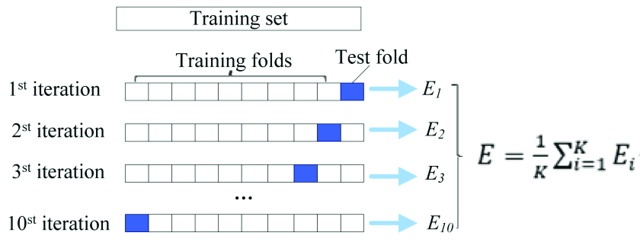

Ten-fold cross validation diagram.
The dataset was divided into ten parts, and nine of them were taken as training data in turn, and one was used as test data for testing. The average value E of the ten-groups test results is calculated as an estimate of the model accuracy and is used as a performance indicator for the current K-fold cross-validation model. Where E i represents the cross-validation error of the ith group.

Confusion Matrix

A confusion matrix is a technique for summarizing the performance of a classification algorithm. Classification accuracy alone can be misleading if you have an unequal number of observations in each class or if you have more than two classes in your dataset. Calculating a confusion matrix can give you a better idea of what your classification model is getting right and what types of errors it is making.

What is a Confusion Matrix?
A confusion matrix is a summary of prediction results on a classification problem.
The number of correct and incorrect predictions are summarized with count values and broken down by each class. This is the key to the confusion matrix.
The confusion matrix shows the ways in which your classification model
is confused when it makes predictions.
It gives you insight not only into the errors being made by your classifier but more importantly the types of errors that are being made.
It is this breakdown that overcomes the limitation of using classification accuracy alone.
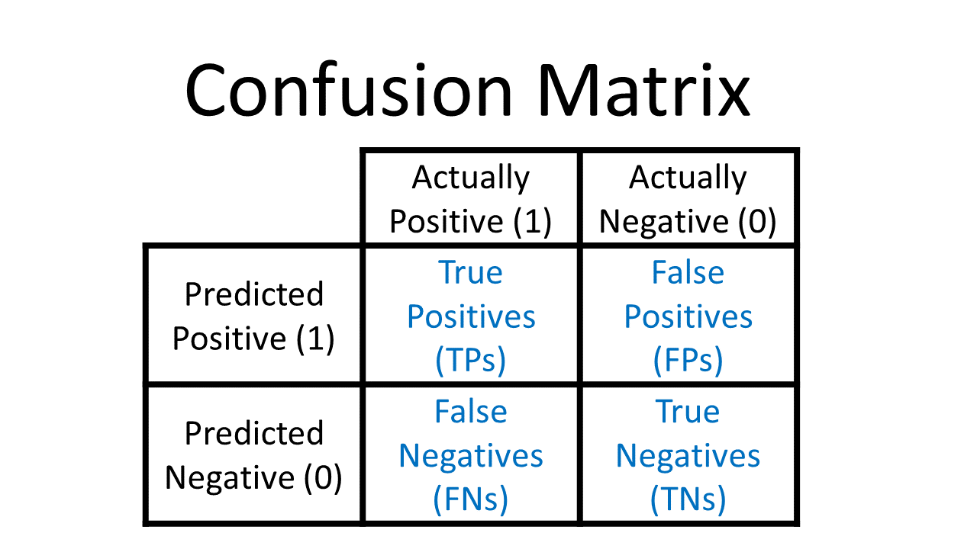
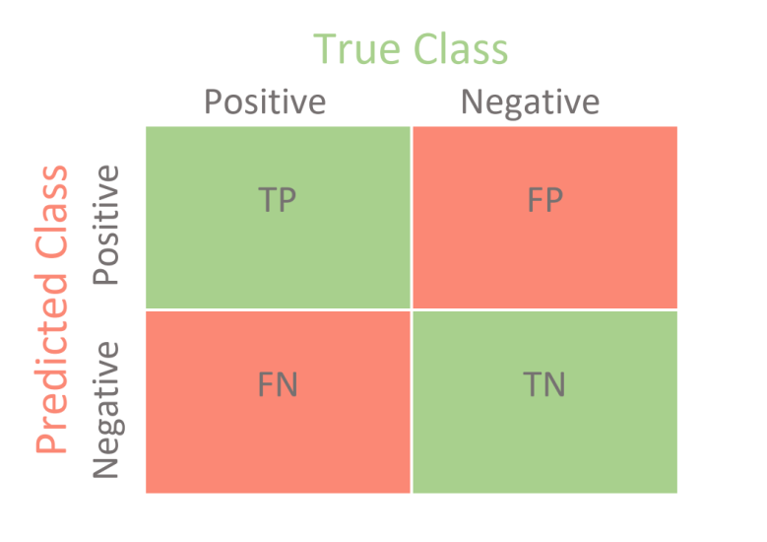

How to Calculate a Confusion Matrix
Below is the process for calculating a confusion Matrix.
- You need a test dataset or a validation dataset with expected outcome values.
- Make a prediction for each row in your test dataset.
- From the expected outcomes and predictions count:
  - The number of correct predictions for each class.
  - The number of incorrect predictions for each class, organized by the class that was predicted.
These numbers are then organized into a table, or a matrix as follows:
- Expected down the side: Each row of the matrix corresponds to a predicted class.
- Predicted across the top: Each column of the matrix corresponds to an actual class.
The counts of correct and incorrect classification are then filled into the table.
The total number of correct predictions for a class go into the expected row for that class value and the predicted column for that class value.
In the same way, the total number of incorrect predictions for a class go into the expected row for that class value and the predicted column for that class value.
Example:
If a classification system has been trained to distinguish between cats, dogs and rabbits, a confusion matrix will summarize the results of testing the algorithm for further inspection. Assuming a sample of 27 animals — 8 cats, 6 dogs, and 13 rabbits, the resulting confusion matrix could look like the table below:
 | In this confusion matrix, of the 8 actual cats, the system predicted that three were dogs, and of the six dogs, it predicted that one was a rabbit and two were cats. We can see from the matrix that the system in question has trouble distinguishing between cats and dogs, but can make the distinction between rabbits and other types of animals pretty well. All correct predictions are located in the diagonal of the table (highlighted in bold), so it is easy to visually inspect the table for prediction errors, as they will be represented by values outside the diagonal.
   |  | Actual class
   |  | Cat | Dog | Rabbit
  Predicted  class | Cat | 5 | 2 | 0
  Predicted  class | Dog | 3 | 3 | 2
  Predicted  class | Rabbit | 0 | 1 | 11

